## Get started with Keycloak on Podman **1. Task requirement:**

## Integration of Google Auth with KeyCloak as an Identity Provider

1. Creating a login page in Vuejs which will authenticate with google using Keycloak and Keycloak FreeOTP service.

**2. Env detail:**

1. Os:- Ubuntu 20.04.6 LTS

Comment:- Create VM (Install Ubuntu 20.04.6 for Env)

1. Podman- 3.4.2

Comment:-

Reference Link:- <https://www.cyberithub.com/how-to-install-podman-on-ubuntu-20-04-lts-step-by-step/>

1. Nodejs-v16.20.0

Comment:-

Reference Link:- <https://www.stewright.me/2022/01/tutorial-install-nodejs-16-on-ubuntu-20-04/>

# Install NodeJS 16 on Ubuntu 20.04

## Step 1 - Add NodeSource PPA

This command will add PPA sources required to be able to install NodeJS 16 on your Ubuntu 20.04 installation:

curl -s https://deb.nodesource.com/setup\_16.x | sudo bash

## Step 2 - Install NodeJS 16

Run the following command:

sudo apt install nodejs -y

## Step 3 - Confirm the installed version of NodeJS

Run the following command:

node -v

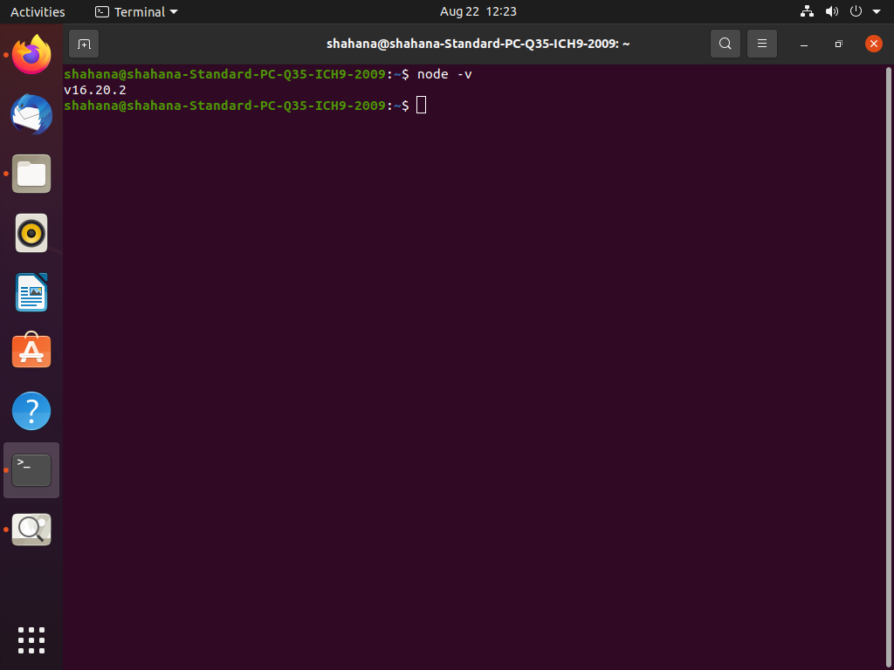

1. Npm-8.19.4

Comment:-

Reference Link:- <https://docs.npmjs.com/cli/v8/configuring-npm/install>

Comment:-

e) Java

Reference link :- <https://www.linode.com/docs/guides/how-to-install-openjdk-on-ubuntu-20-04/>

Following this Command for Install Open jdk #

Step 1 :- sudo apt-get update && sudo apt-get upgrade

Step 2 :- sudo apt-get install openjdk-11-jdk

Step 3 :- sudo apt-get install openjdk-11-jre

Step 4 :- java -version

## **3. Tools and technologies**

1. Keycloak: 21.1.1
2. Google Cloud Paltform(<https://console.cloud.google.com/apis/library>)
3. Vuejs- 3.3.4

**4. Reference link**

<https://keycloakthemes.com/blog/how-to-setup-sign-in-with-google-using-keycloak>

[https://www.keycloak.org/docs/latest/securing\_apps/#\_javascript\_adapter](https://www.keycloak.org/docs/latest/securing_apps/" \l "_javascript_adapter)

## 

## 

## 

## 

## 

## **Google Auth and freeOTP using KeyCloak and Vue**

One of the strong points in favour of Keycloak adoption is the fact that you can setup social signin for your application with a few clicks, no coding requirements needed. Keycloak supports out-of-the box an extensive list of social networks: Google, Github, Facebook, Linkedin, Microsoft, Twitter and many other providers. It’s even flexible enough to support the integration of any OpenId Connect or SAML 2.0 provider.

**Setup Keycloak using podman**

# **Podman**

**Get started with Keycloak on Podman**

## **Before you start**

**Make sure you have Podman installed.**

## **Start Keycloak**

**From a terminal, enter the following command to start Keycloak:**

podman run -p 8080:8080 -e KEYCLOAK\_ADMIN=admin -e EYCLOAK\_ADMIN\_PASSWORD=admin quay.io/keycloak/keycloak:21.1.1 start-dev

(podman run -p 8080:8080 -e KEYCLOAK\_ADMIN=admin -e KEYCLOAK\_ADMIN\_PASSWORD=admin quay.io/keycloak/keycloak:21.1.1 start-dev

)

**This command starts Keycloak exposed on the local port 8080 and creates an initial admin user with the username admin and password admin.**

**Next, log into Keycloak Administration Console, available at: http://localhost:8080**

**In your first Login, you will be requested to create an administration user:**

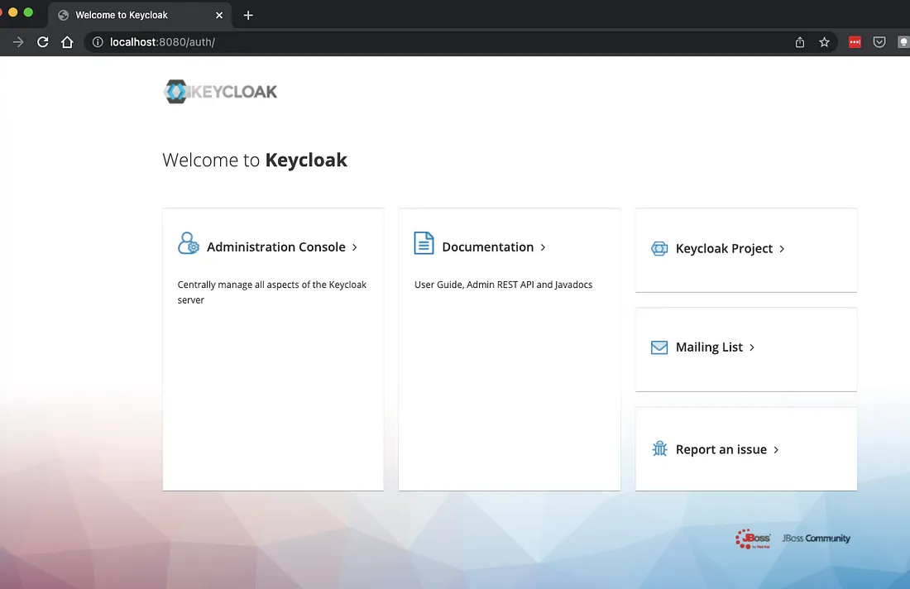

**==================================================================================**

**Next, login with the admin user you have just created:**

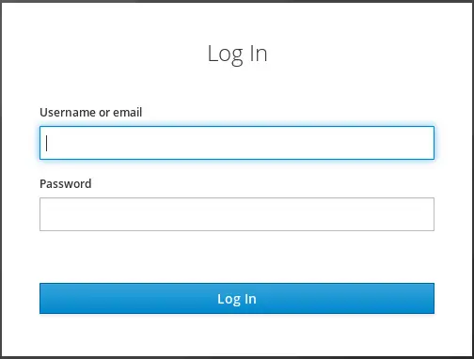

# **The Keycloak server**

Once you log in, Keycloak shows you the **Master realm.**

**Realm Definition .**

A realm manages a set of users, credentials, roles, and groups. A user belongs to and logs into a realm. Realms are isolated from one another and can only manage and authenticate the users that they control.

1. **Create Realm for Google Authentication.**

Procedure

1. Point to the top of the left pane.
2. Click **Create Realm**.  
     
     
    Add realm menufile:///tmp/mume2023717-2620-1ac73x.ewp7q.html

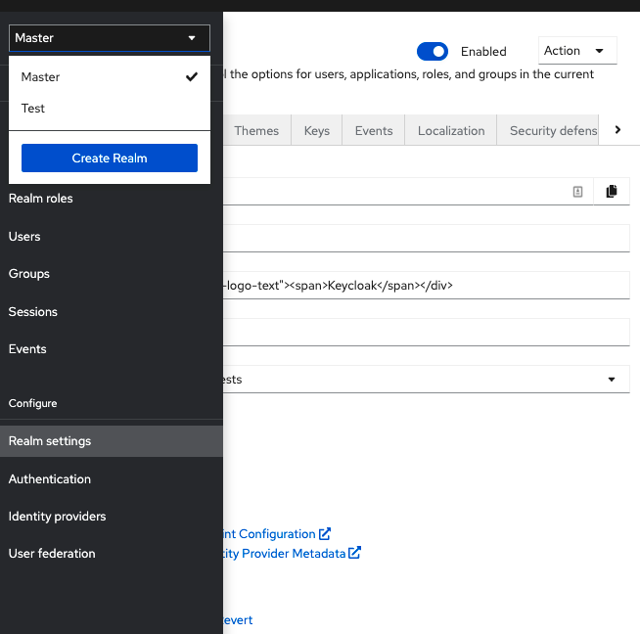

1. Enter a name for the realm.
2. Click **Create**.  
     
     
    **Create realm**

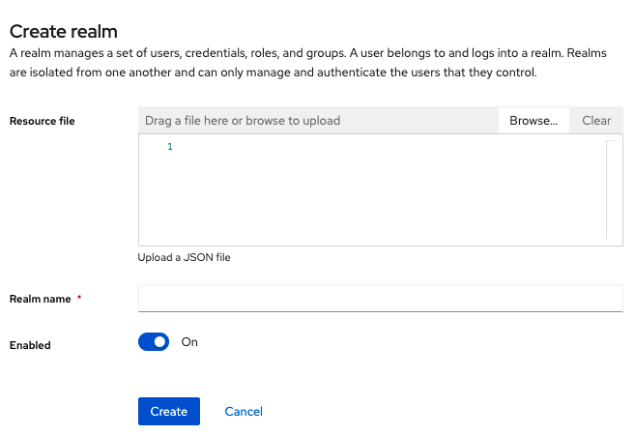

The current realm is now set to the realm you just created. You can switch between realms by clicking the realm name in the menu.

### **Configuring SSL for a realm**

Each realm has an associated SSL Mode, which defines the SSL/HTTPS requirements for interacting with the realm. Browsers and applications that interact with the realm honor the SSL/HTTPS requirements defined by the SSL Mode or they cannot interact with the server.

Procedure

1. Click **Realm settings** in the menu.
2. Click the **General** tab.  
     
     
    **General tab**

**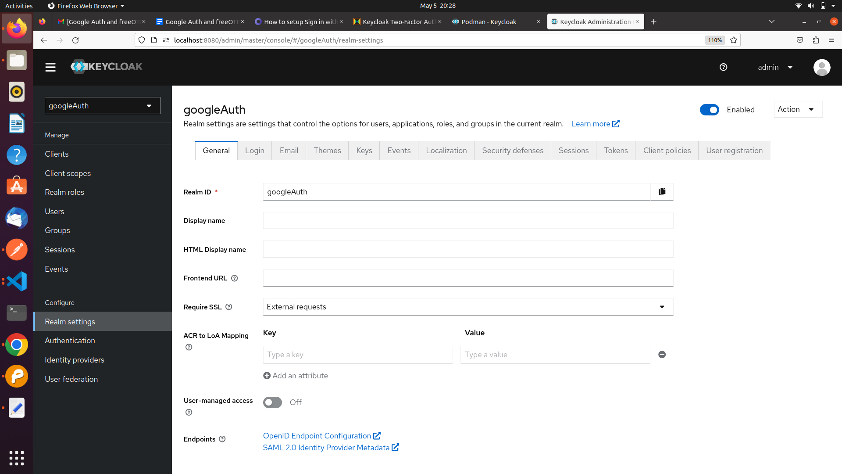**

1. Set **Require SSL** to one of the following SSL modes: **example**  
     
   * **External requests** Users can interact with Keycloak without SSL so long as they stick to private IP addresses such as localhost, 127.0.0.1, 10.x.x.x, 192.168.x.x, and 172.16.x.x. If you try to access Keycloak without SSL from a non-private IP address, you will get an error.
   * **None** Keycloak does not require SSL. This choice applies only in development when you are experimenting and do not plan to support this deployment.
   * **All requests** Keycloak requires SSL for all IP addresses.

**3. Add Identity Provider from the list Choose Google**

**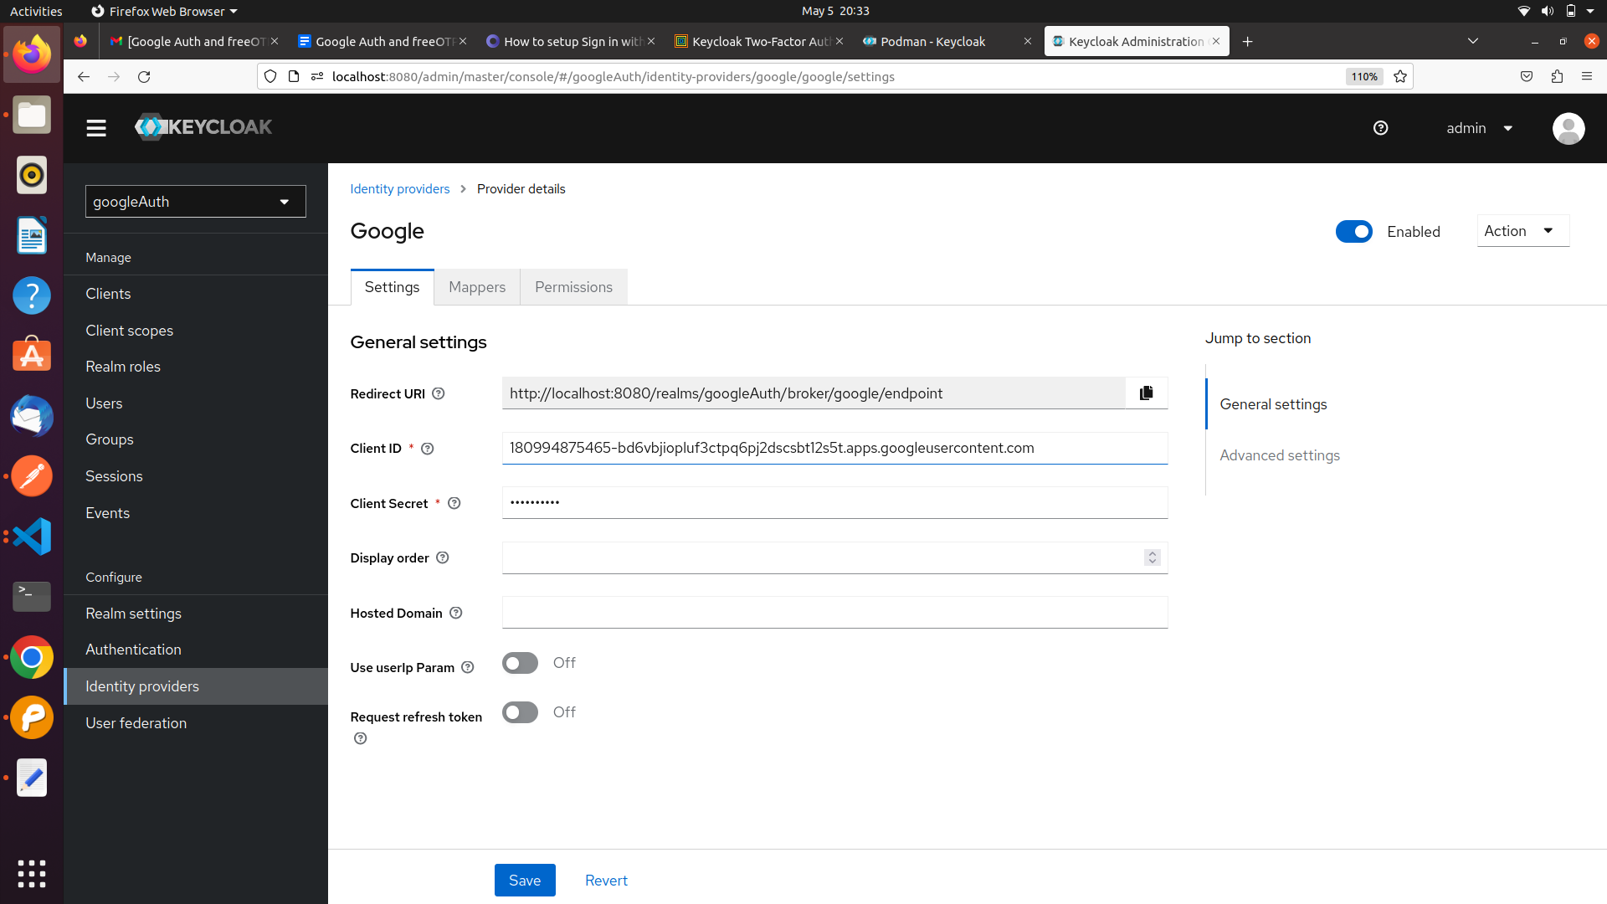4. Copy Redirect URI to be used for google configuration.**

**Setup Google configuration for Authentication**

* Login with your gmail account the link <https://console.cloud.google.com/>
* In the Google Cloud console, go to Menu > click on API and Services option.

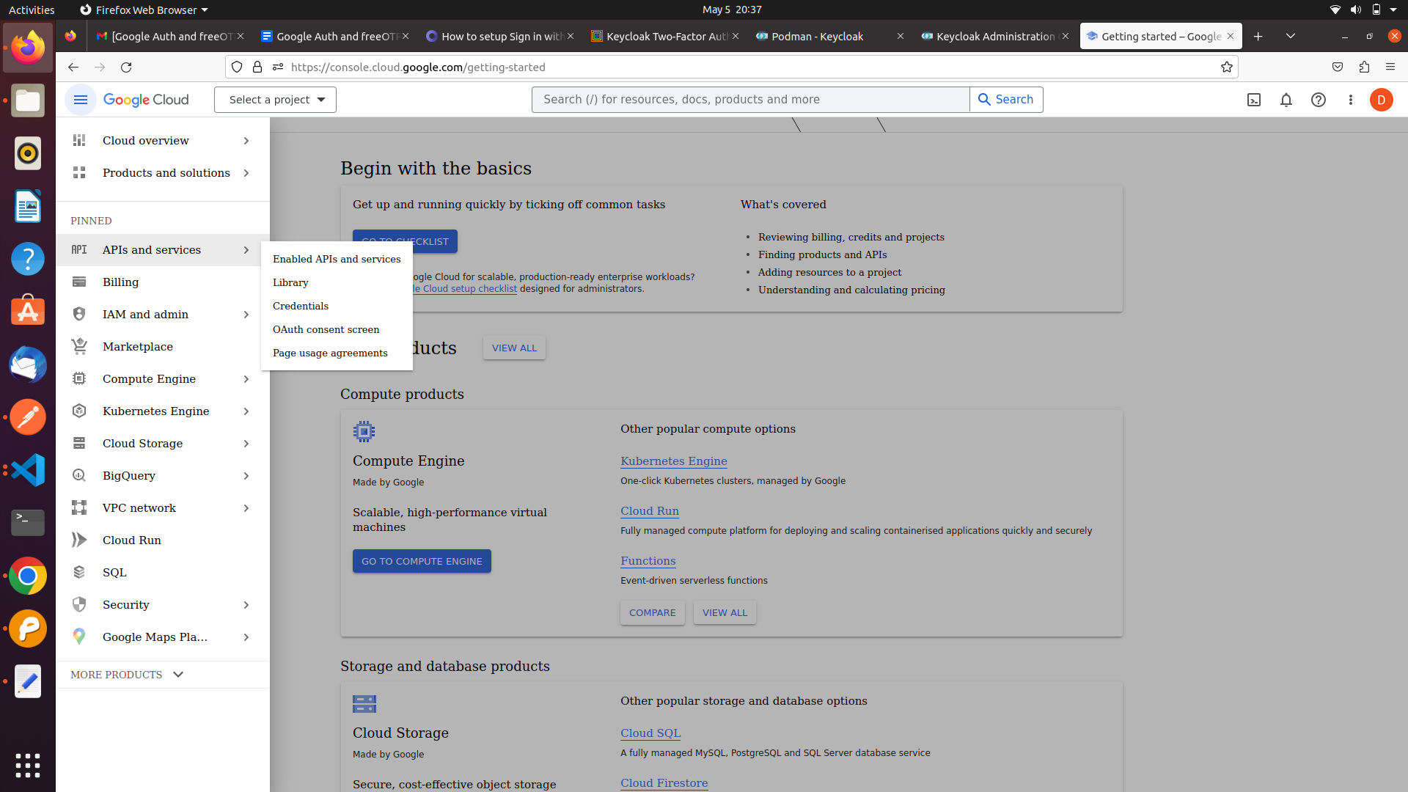

* Click on the Select a **create a Project** at the top left and create a new project.
* In the **Project Name** field, enter a descriptive name for your project.

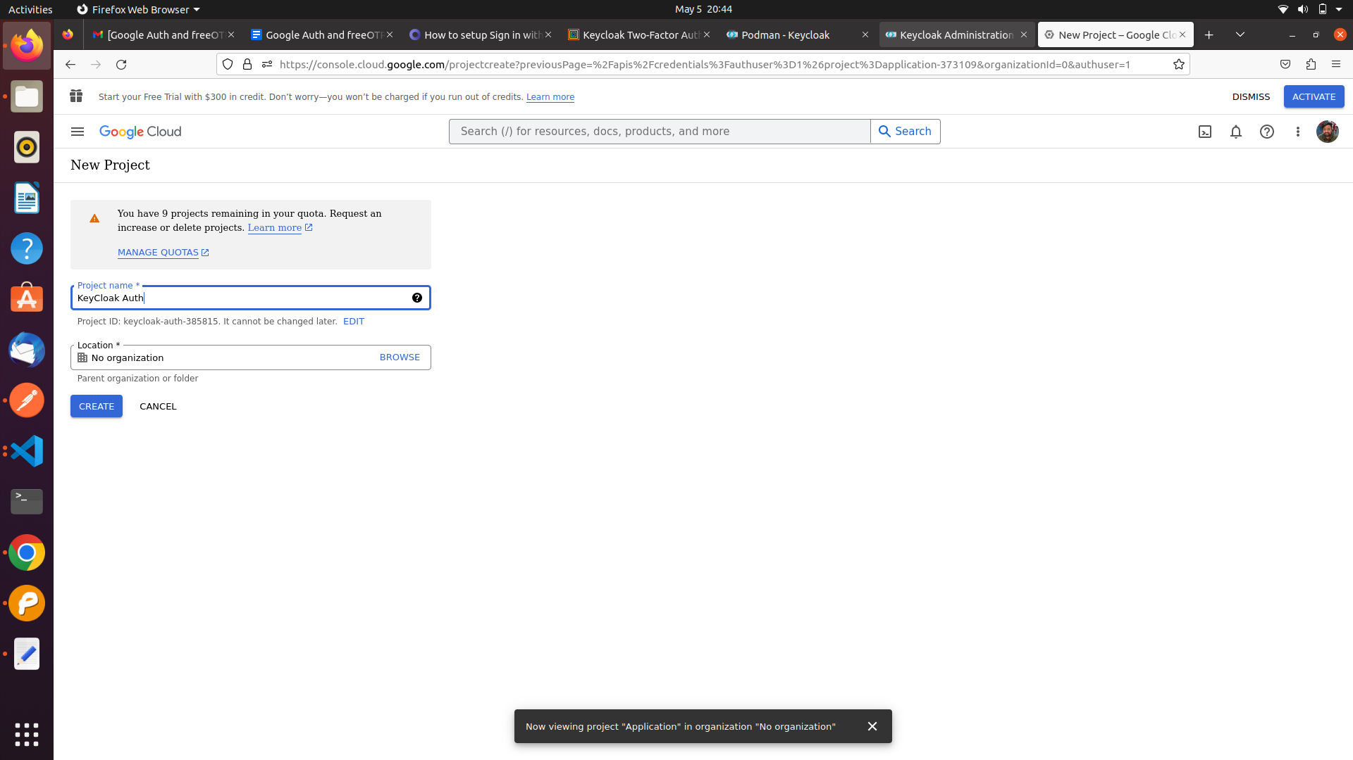

Click on the Oauth consent screen and configure it.

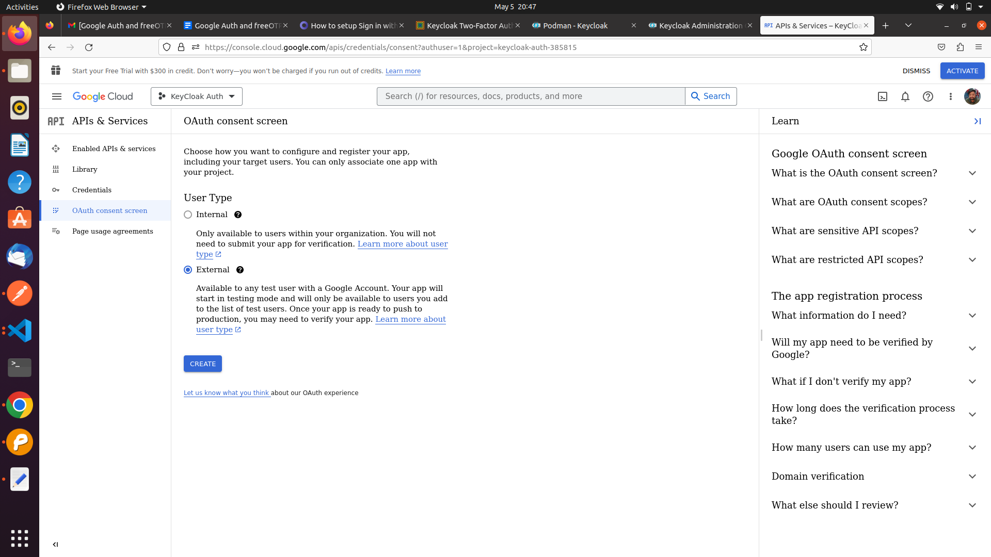

I'm

**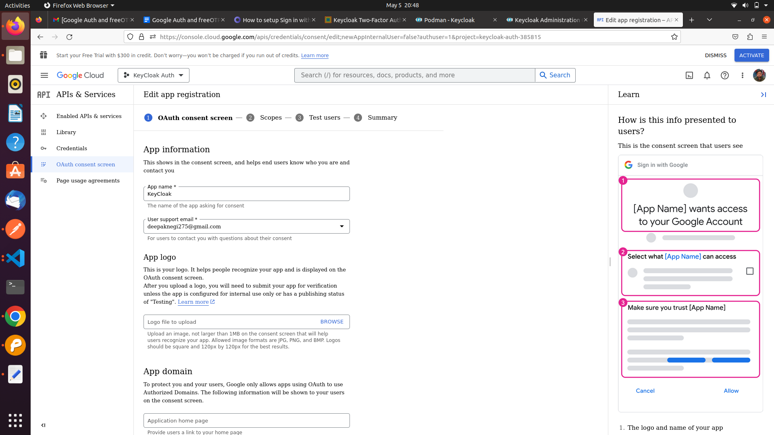**

**8. Setting up the credentials to get clientID and client secret**

**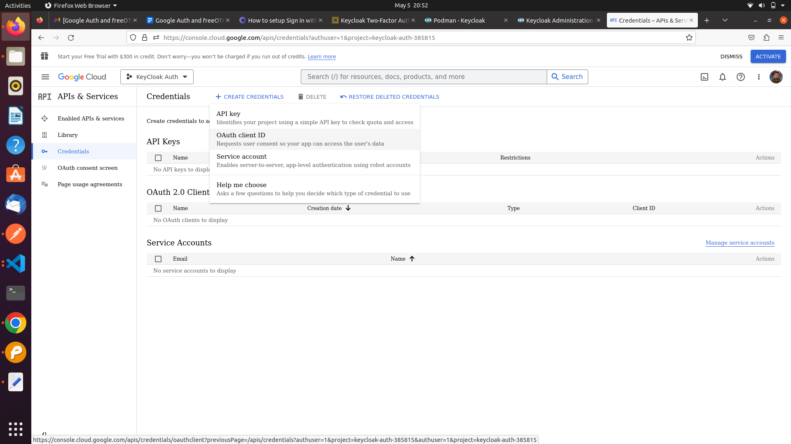Click on the Credentials -> Create Credentials-> OAuth Client ID-> Application Type->**

**Web Application**

**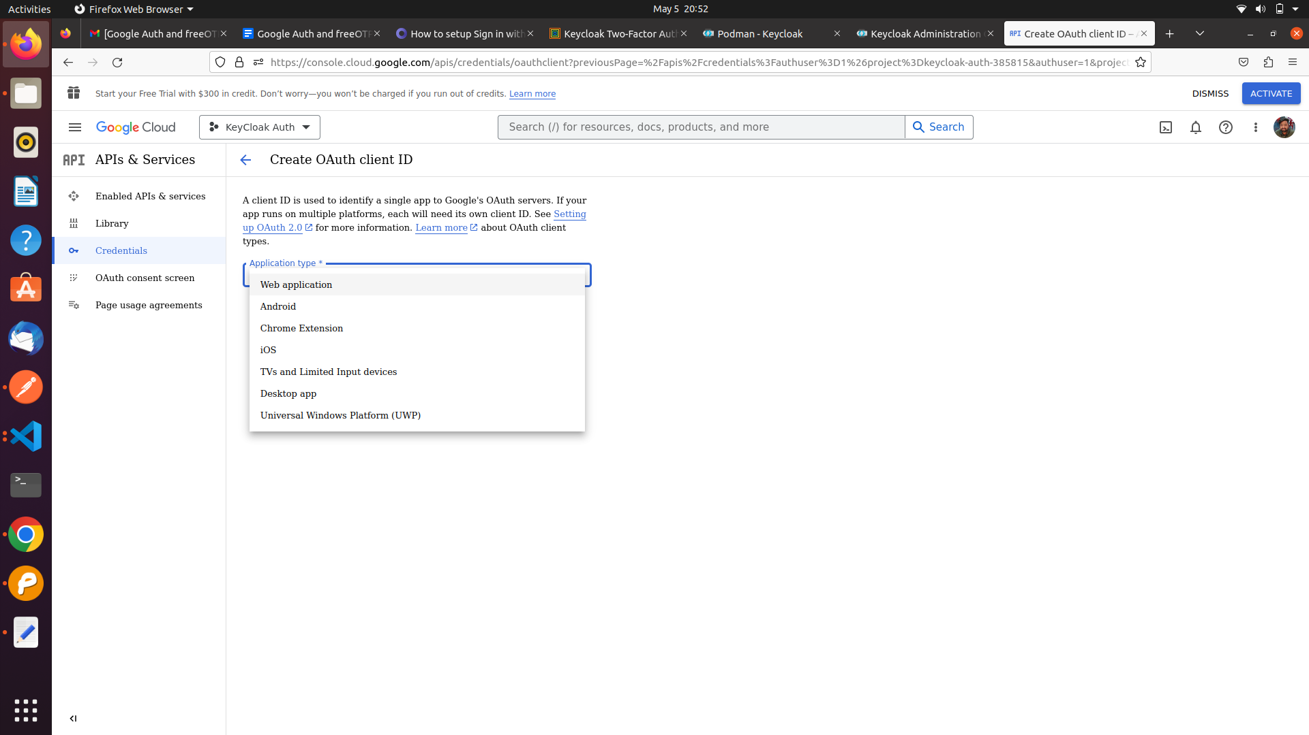**

**9. Paste the redirect url which we copied from keycloak in the Authorized Redirect URL field.**

**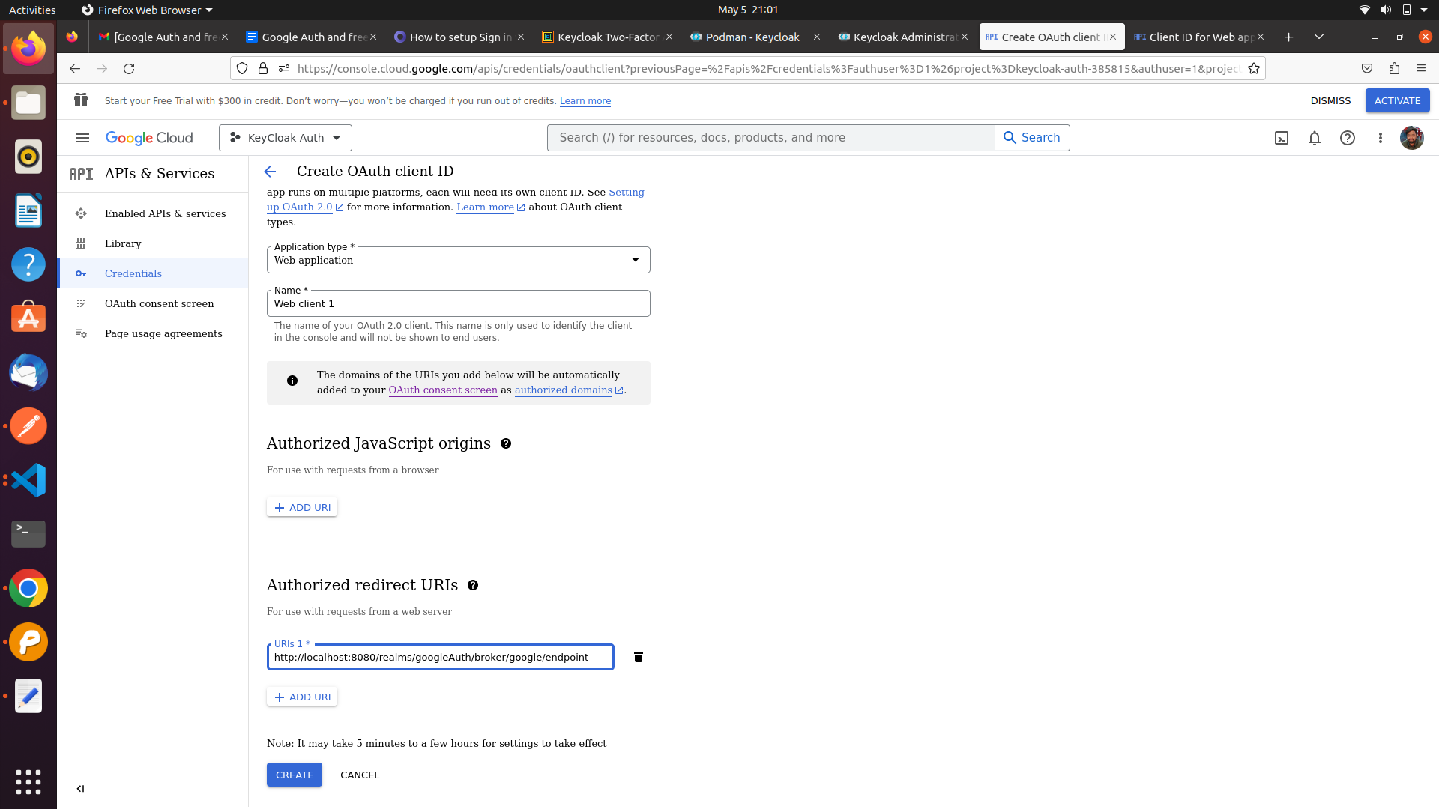**

**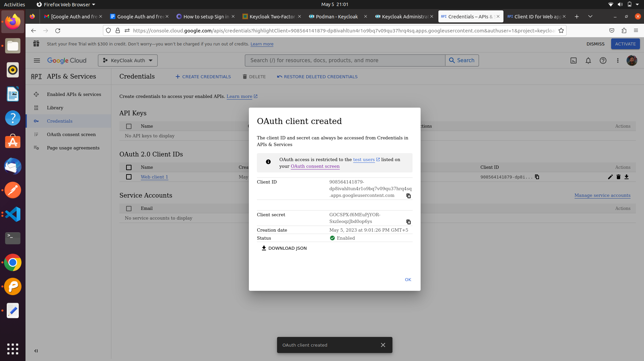10. Click on Create then you will get client ID and client Secret. Copy both to be used in keycloak configuaration.**

**11. Paste the ClientID and Client secret in google identity provider configuration.**

​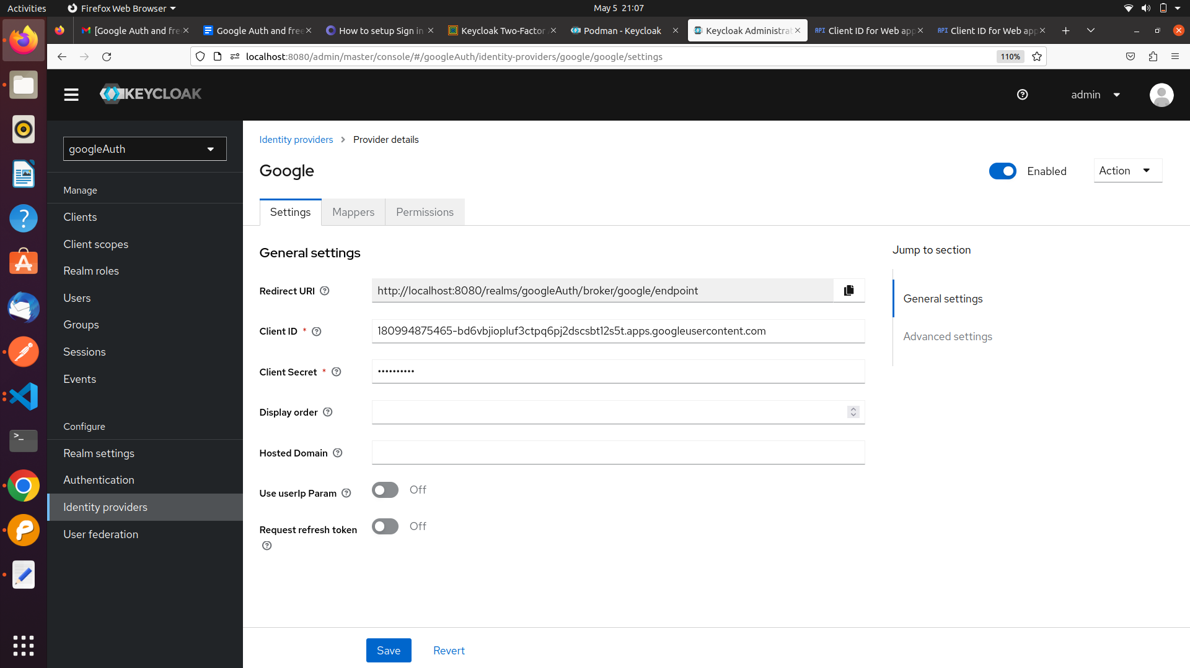​

**12. Create a Client in Keycloak and configure the Access Setting.**

**Note- Input your Vue URL in the Valid Redirect URI fields, and set Web Origin to \***

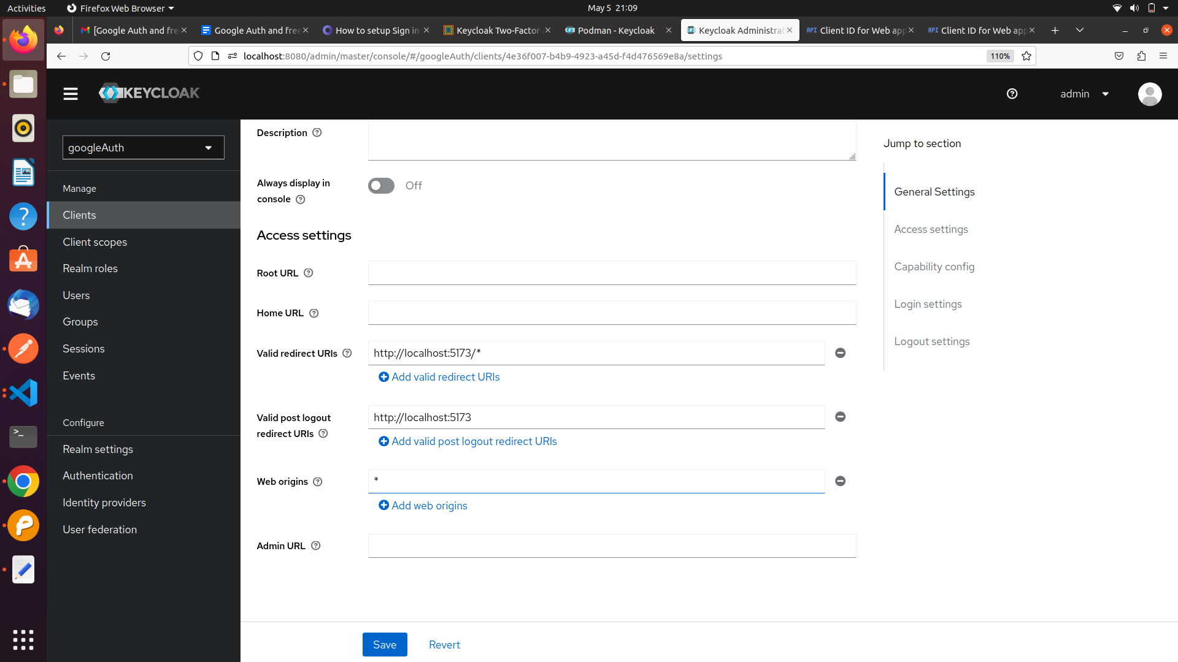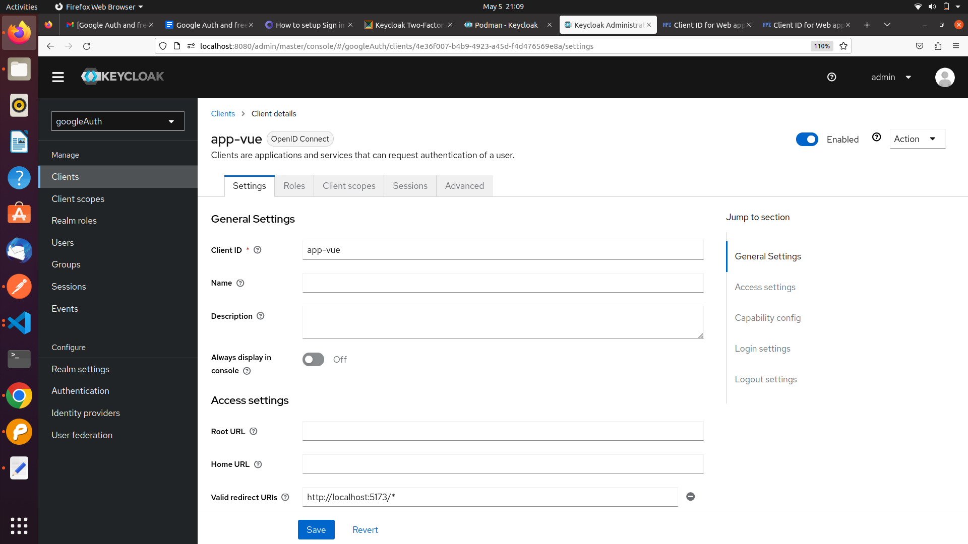​​

**13. Now we have to setup the flow for authentication and post authentication of Identity provider.**

**Your Realm-> Authentication-> first broker login->Click on the 3 dots ->Choose Duplicate->Named the Duplicate Copy to any.**

**14. Click on first broker login match the flow as shown below**

​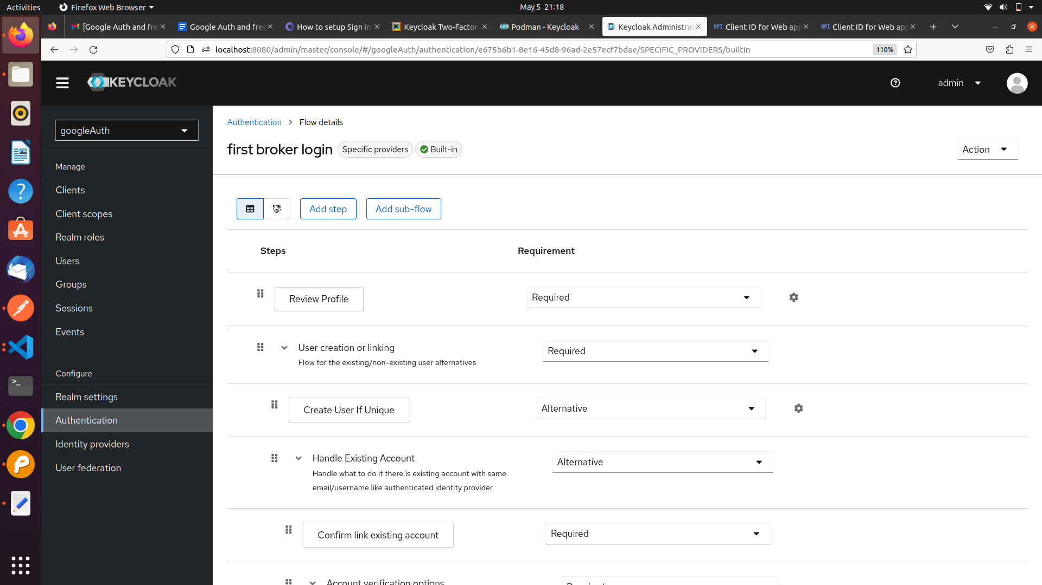​

**15. Click on the Copy of the first broker link. Remove all the steps and add OTP Form Steps**

**As shown below**

**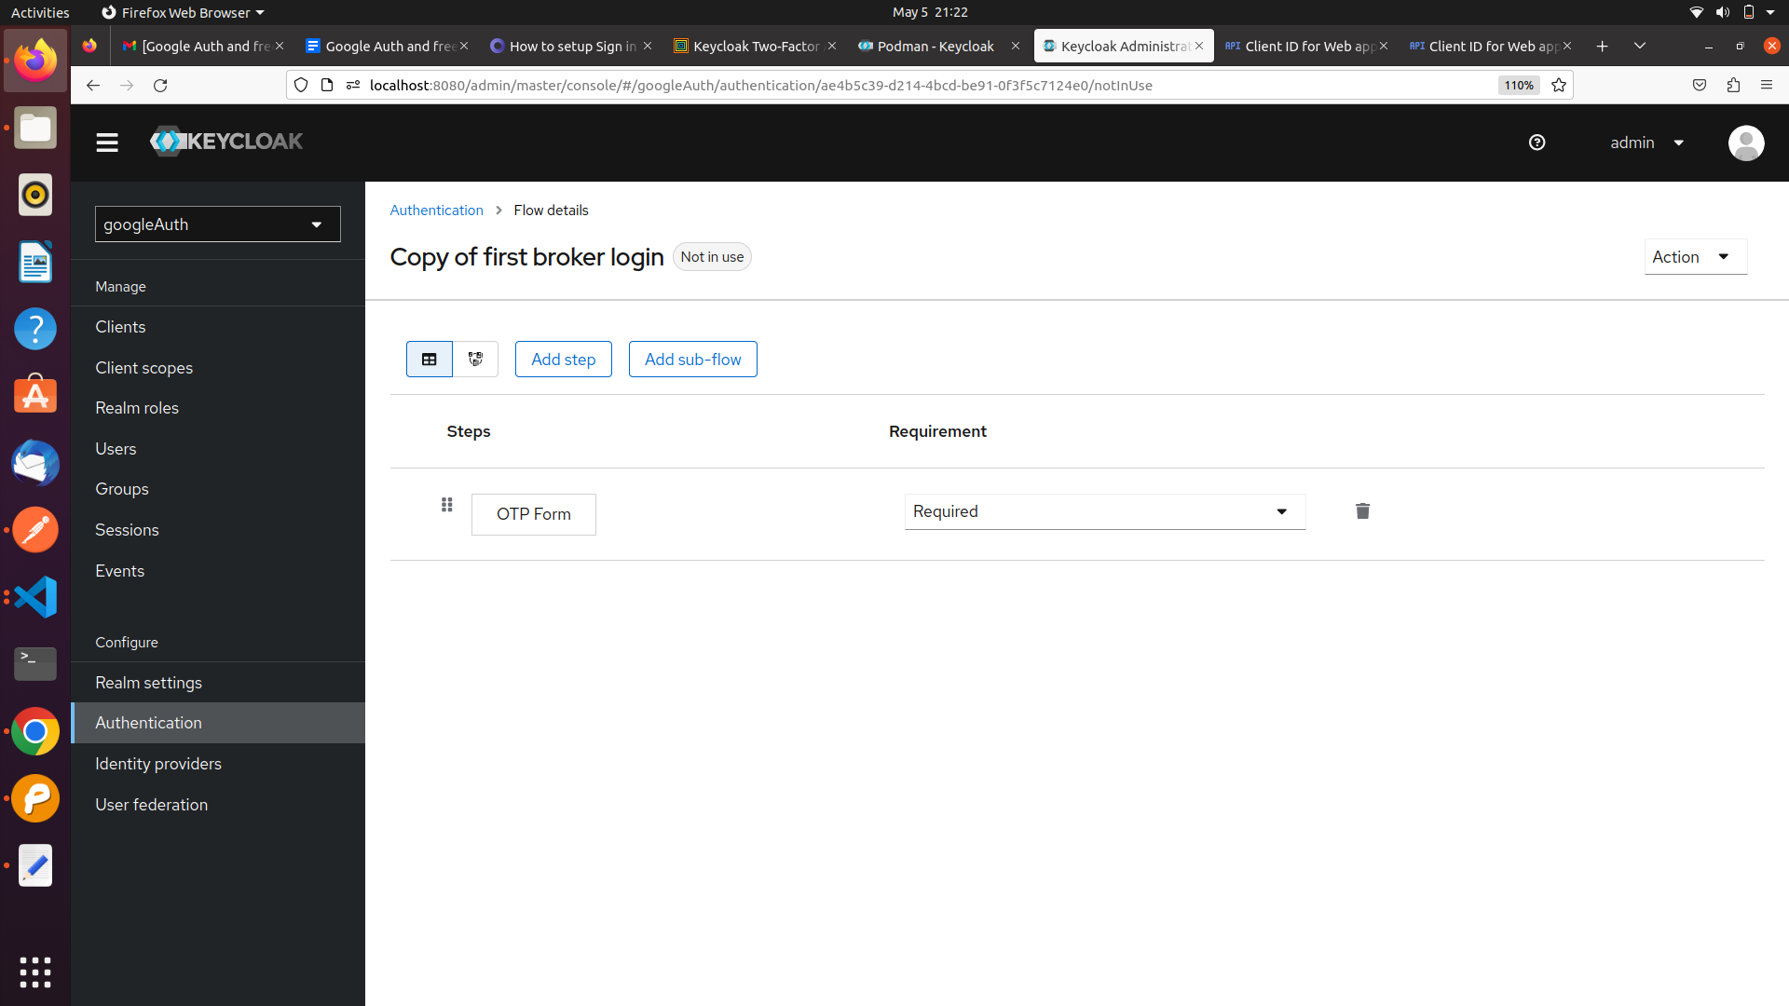**

**16. Setup the Flows in google identity provider configuration.**

**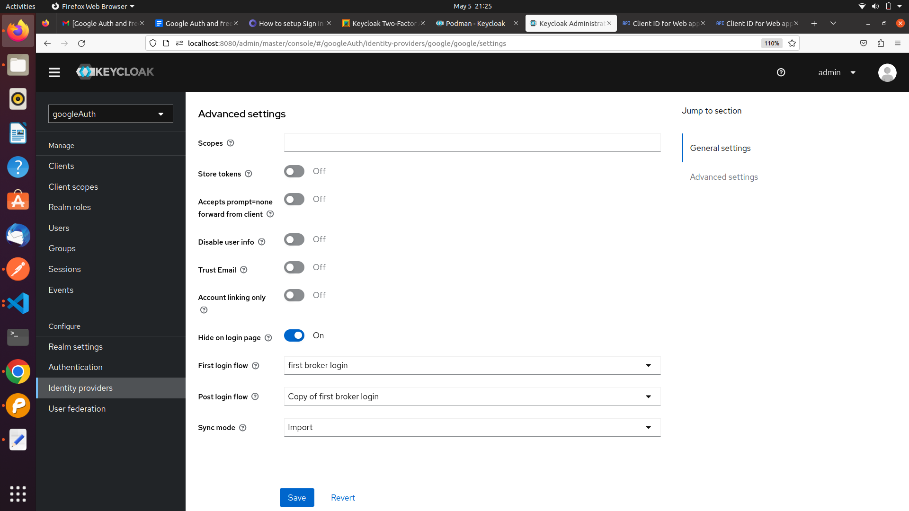Click on Identity Provider->google->Advance Setting->First Login Flow-> Choose first borken login-> Post login flow-> Choose Copy of first broken login -> Save**

**18. Setting up the FreeOTP Configuration in keycloak.**

**Click on Authentication-> Required Action-> Configure OTP -> Enable → ON and Set as default Action→ ON.**

**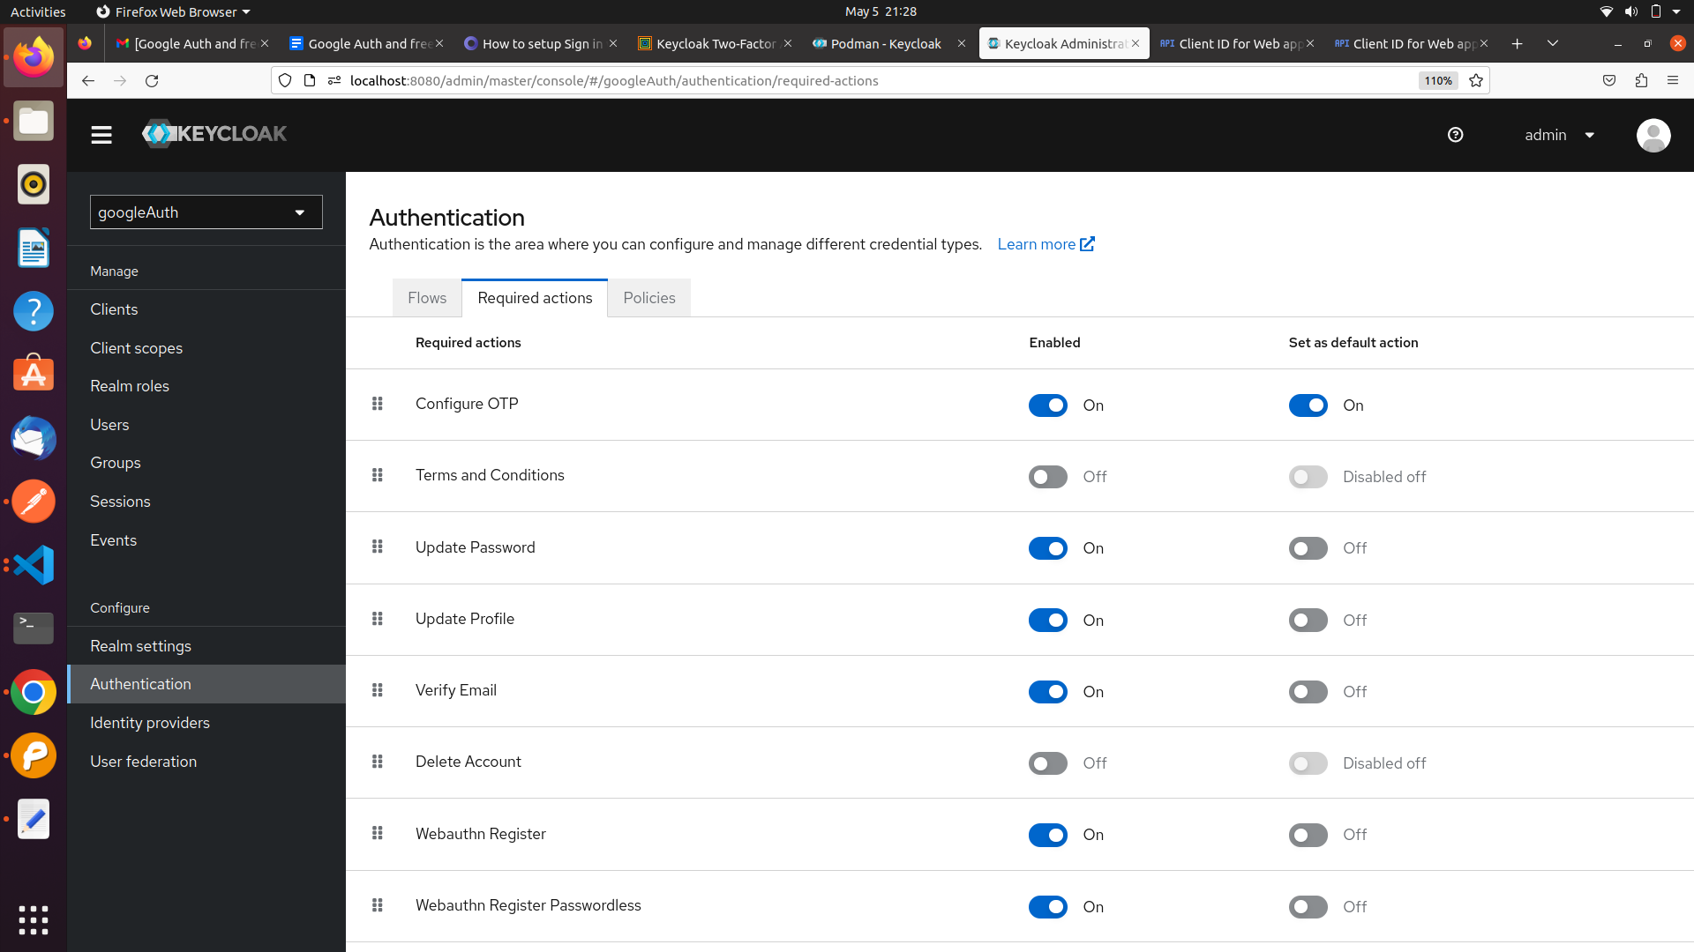**

**Verify the OTP Policy is same as shown below.**​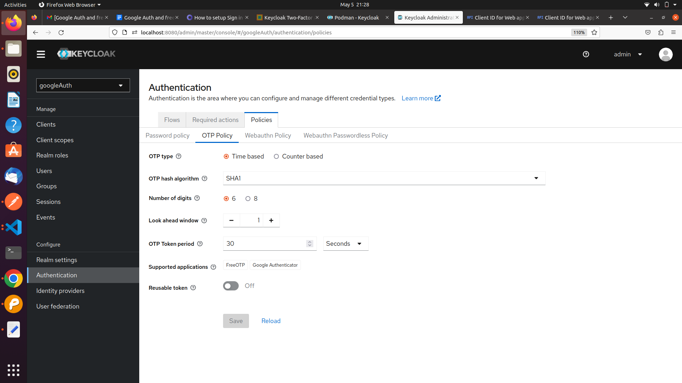​

**Missing main.js**

**Authenticate with Vue and Vite**

**user@user-pc:~$ node --version**

**v16.19.1**

1. **> npm init vue@latest**

**> ✔ Project name: … <your-project-name>**

**✔ Add TypeScript? … No / Yes**

**✔ Add JSX Support? … No / Yes**

**✔ Add Vue Router for Single Page Application development? … No / Yes**

**✔ Add Pinia for state management? … No / Yes**

**✔ Add Vitest for Unit testing? … No / Yes**

**✔ Add Cypress for both Unit and End-to-End testing? … No / Yes**

**✔ Add ESLint for code quality? … No / Yes**

**✔ Add Prettier for code formatting? … No / Yes**

**Scaffolding project in ./<your-project-name>...**

**Done.**

**> cd <your-project-name>**

**> npm install**

**> npm run dev**

1. **Install keycloak adapter in Vuejs.**

**> npm install keycloak-js@12.0.4**

**Comment ➖**

1. **Other Dependencies to install**
2. **npm install axios**
3. **npm install vue-router**
4. **Create auth.js file in vue for keycloak configuration**

**and paste the code shown below.**

**Comment ➖**

**File Path: src/auth.js**

**auth.js**

import Keycloak from 'keycloak-js';

const keycloak = new Keycloak({

url: 'http://localhost:8080',

realm: 'googleAuth',

clientId: 'app-vue',

});

export default keycloak

1. **Create Login Page in vue**

**Comment:-**

1. **Create a file LoginPage.vue**

**File Path: src/components/LoginPage.vue**

**Login Page.Vue**

<template>

<div class="box-form">

<div class="left">

<div class="overlay">

<h1 style="margin-top:40px;">Keen</h1>

<h1 style="margin-left: 170px; margin-top:1px;">Able</h1>

<span>

<p style="text-align: center; font-weight: bold;">Always Been Open!</p>

</span>

</div>

</div>

<div class="right">

<h5>Login</h5>

<div class="inputs">

<button @click="login"><i class="fa-brands fa-google" aria-hidden="true"></i> LogIn with Google</button>

</div>

</div>

</div>

</template>

<script>

import keycloak from '../auth'

export default {

name:"LogIn",

methods: {

login() {

keycloak.init().then(() => {

keycloak.login({

idpHint: 'google',

redirectUri: 'http://localhost:5173/home'

});

});

}

}

}

</script>

1. **Create Home Page after successful login to redirect.**

**Comment:-**

1. **Create a file HomePage.vue**

**File Path:- src/components/HomePage.vue**

**HomePage.vue**

<template>

<div>

<h1>

Welcome

<p></p>

{{ usermail }}

</h1>

<button type="button" class="btn btn-primary" @click="logOut">

LogOut

</button>

</div>

</template>

<script>

import keycloak from "../auth";

import axios from "axios";

export default {

name: "HomePage",

data() {

return {

usermail: "",

refreshToken: "",

auth:false

};

},

created() {

keycloak

.init({

onLoad: "check-sso",

silentCheckSsoRedirectUri:

window.location.origin + "/silent-check-sso.html",

pkceMethod: "S256",

})

.then((authenticated) => {

if (authenticated) {

console.log("User is authenticated");

keycloak.loadUserProfile().then((profile) => {

console.log("User profile", profile);

this.usermail = profile.email;

console.log("typeof", typeof passpof);

const accessToken = keycloak.token;

this.refreshToken = keycloak.refreshToken;

console.log("hii deepak", accessToken);

console.log("hii deepak", refreshToken);

this.auth=true

});

} else {

console.log("User is not authenticated");

}

})

.catch((err) => {

console.error("Error initializing Keycloak", err);

});

},

methods: {

logOut() {

const headers = {

"Content-type": "application/x-www-form-urlencoded",

};

var params = new URLSearchParams();

params.append("client\_id", "app-vue");

params.append("refresh\_token", this.refreshToken);

axios

.post(

"http://localhost:8080/realms/googleAuth/protocol/openid-connect/logout?redirect\_uri=http%3A%2F%2Flocalhost%3A5173",

params,

{ headers }

)

.then((response) => {

console.log("hii there", response.data);

window.location.href = "http://localhost:5173";

})

.catch((e) => {

console.log("eorro")

});

},

},

};

</script>

**Comment :-**

**6. Create a route for routing across the page.**

1. **Create router folder if not exist inside src**

**Path: src/router**

1. **Create a index.js file inside router folder**

**Path: src/router/index.js**

**Paste the code in index.js file**

**Index.js**

**import { createWebHistory, createRouter } from "vue-router";**

**import Home from '../components/HomePage.vue';**

**import LoginPage from '../components/LoginPage.vue';**

**// import About from "@/views/About.vue";**

**const routes = [**

**{**

**path: "/home",**

**name: "Home",**

**component: Home,**

**},**

**{**

**path: "/",**

**name: "Login",**

**component: LoginPage,**

**}**

**];**

**const router = createRouter({**

**history: createWebHistory(),**

**routes,**

**});**

**export default router;**

**Comment:-**

**7. Importing route in main.js file i.e your main.js file should look like this:**

**Main.js**

**import { createApp } from 'vue'**

**import App from './App.vue'**

**import router from './router'**

**import './assets/main.css'**

**const app = createApp(App)**

**app.use(router)**

**app.mount('#app')**

**Running the application and Authenticate with Google and FreeOTP**

**> npm run dev**

**Comment ➖**

**user@user-pc:~/your-project$ npm run dev**

**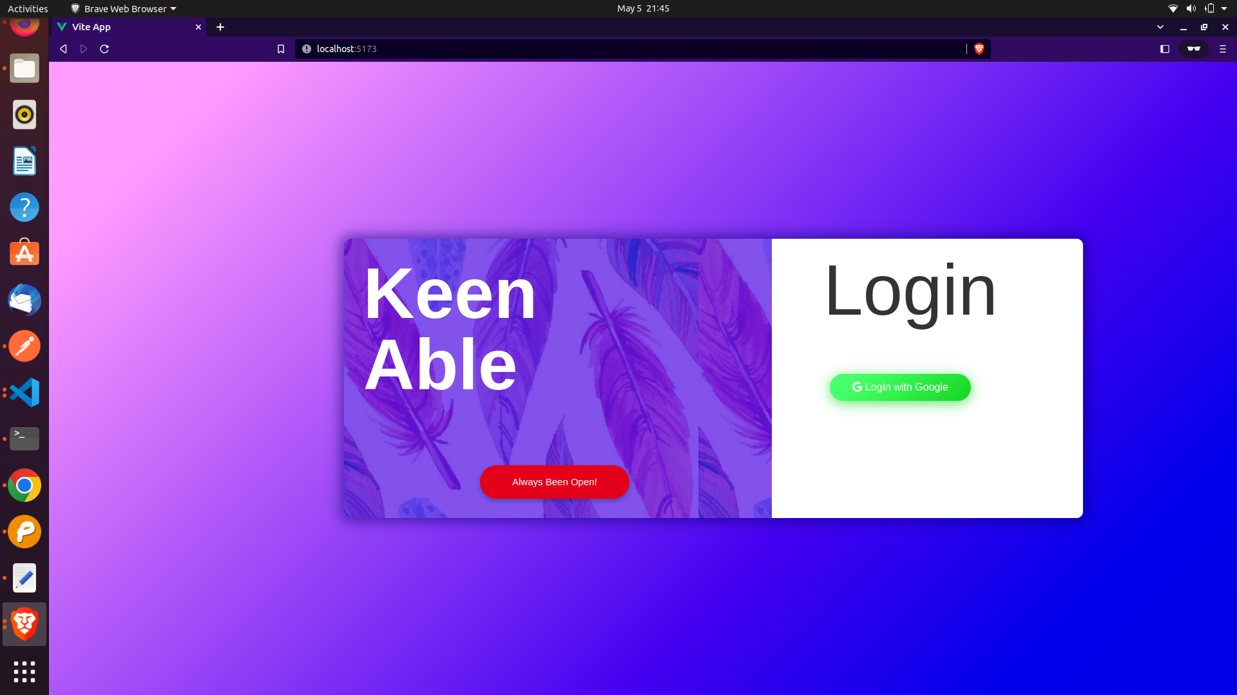**

**.**

**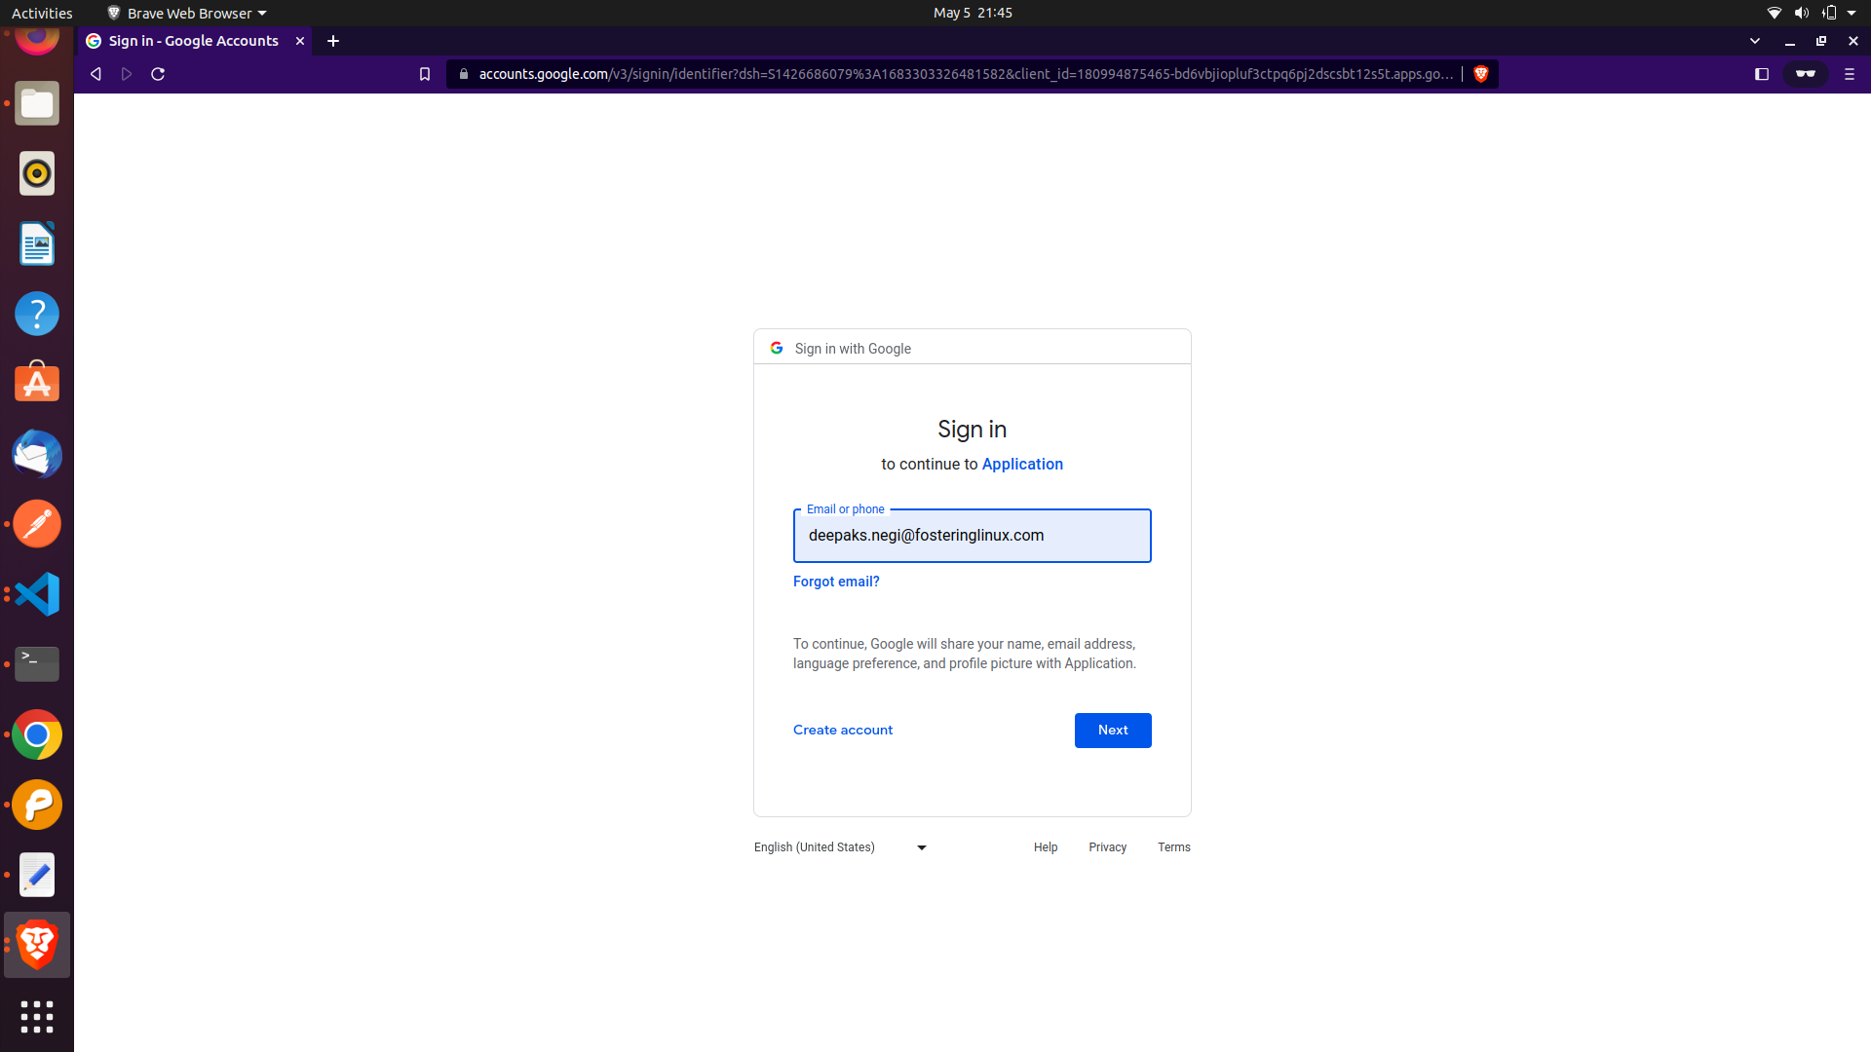**

**Install FreeOTP app from play store and scan it for first time. Input 6 digit Code**

**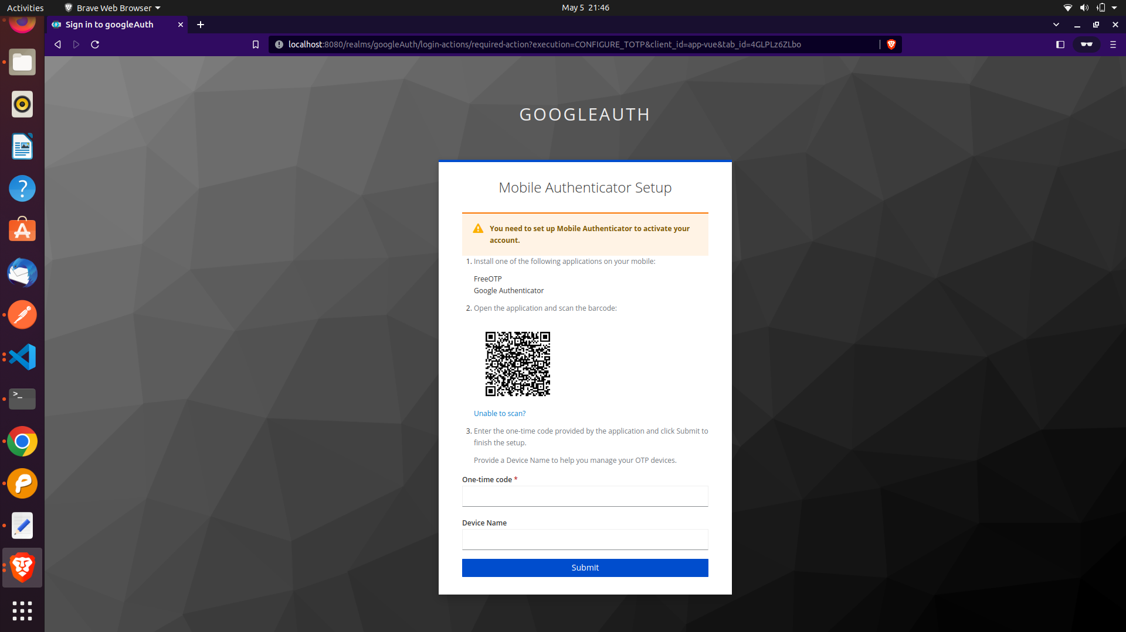**

**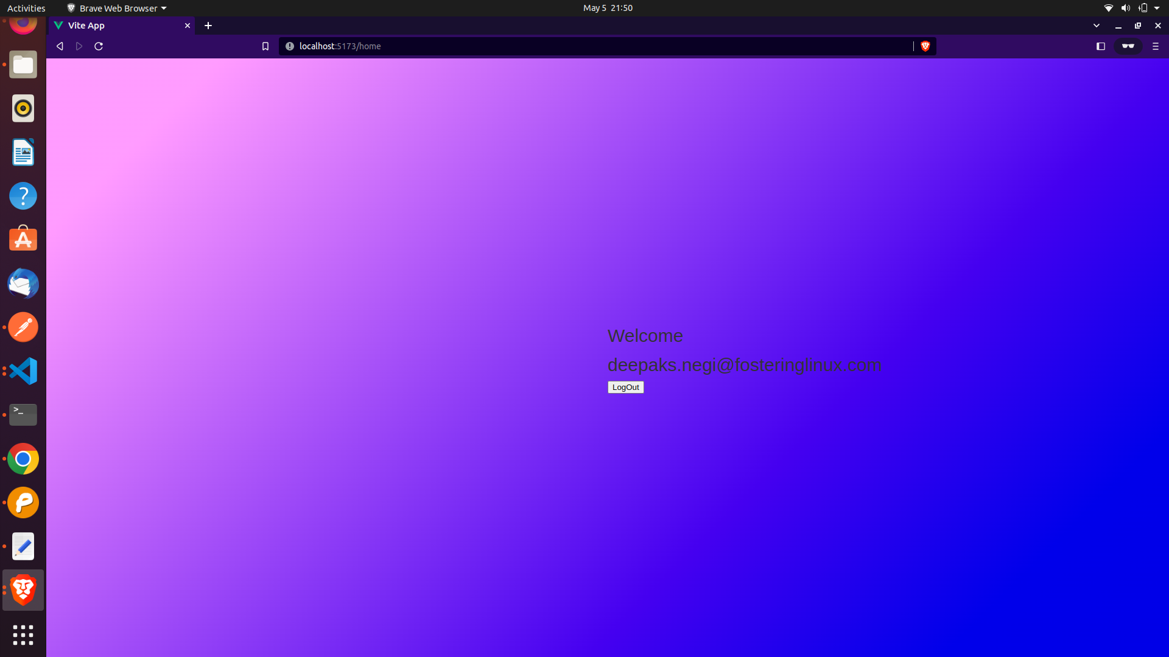Successfully Logged In…**